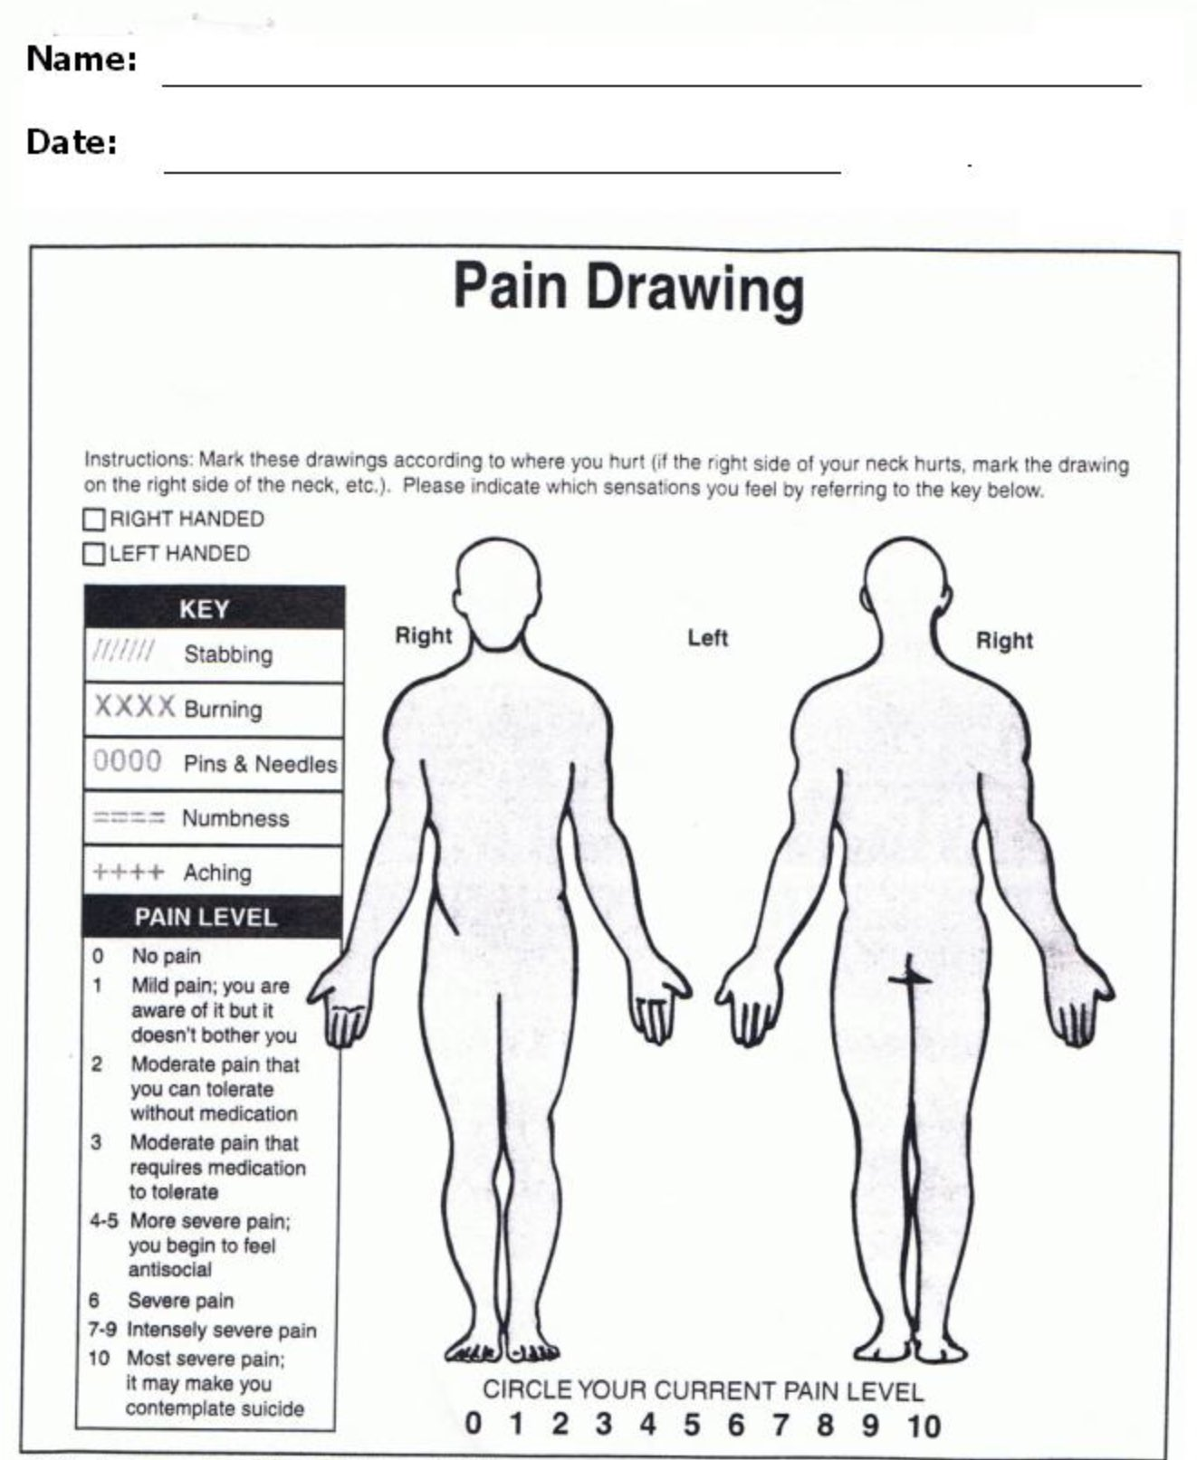

**Direct Contraindications**

* Steroid or Cortisione Shot in last 7 days
* Pregnancy (treatment of low back or abdomen)
* Infections and Tumor Tissue or in the Pathways of the Lungs or Brain
* Growth Plates and Active Cancer
* Anti-coagulants (blood thinnners)- therapy can create bruising **(Relative)**

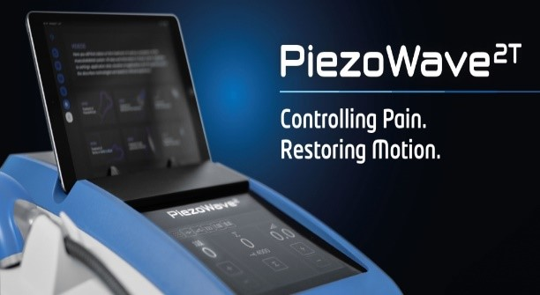



**Sleppy Chiropractic Family Wellness Center**

**Dr. Matthew Sleppy and Dr. Evan Ludwig**

**Patient Signature:** _______________________________ **Date:** __________________